**LAB CYCLE 1**

1. Program to Print all non-Prime Numbers in an Interval

**CODE:**

**#21mca006**

**#non-prime numbers**

**print("21mca006- Anish Anjali")**

**lower=int(input("Enter a value for lower digit : "))**

**upper=int(input("Enter a value for upper digit : "))**

**print("The Non Prime Numbers are : ")**

**for i in range(lower,upper):**

**for j in range(2,upper):**

**if(i%j==0) and(j!=i):**

**print(i)**

**break**

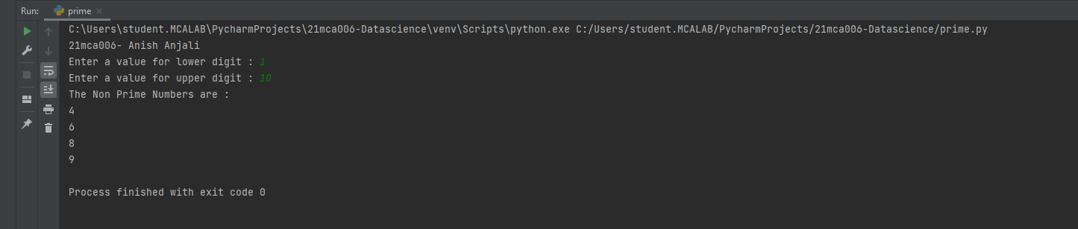

1. Program to print the first N Fibonacci numbers.

**CODE:**

**#21mca006**

**#Fibonacci series**

**print("21mca006- Anish Anjali")**

**n=int(input("Enter limit: "))**

**f1 = 0**

**f2 = 1**

**for x in range(0, n):**

**print(f2, end=" ")**

**next = f1 + f2**

**f1 = f2**

**f2 = next**

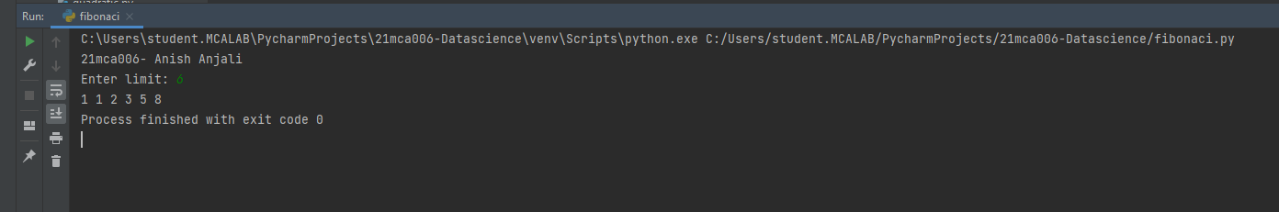

1. Given sides of a triangle, write a program to check whether a given triangle is an isosceles, equilateral or scalene.

**CODE:**

**#21mca006**

**#triangle**

**print("21mca006- Anish Anjali")**

**s1 = int(input("Enter the length for Side 1:"))**

**s2 = int(input("Enter the length for Side 2:"))**

**s3 = int(input("Enter the length for side 3:"))**

**if s1 == s2 and s2 == s3 and s3==s1:**

**print("The given lengths are of an Equilateral triangle ")**

**elif s1 == s2 or s1 == s3 or s2==s3:**

**print("The given lengths are of an Isosceles triangle")**

**else:**

**print("The given lengths are of a Scalar triangle")**

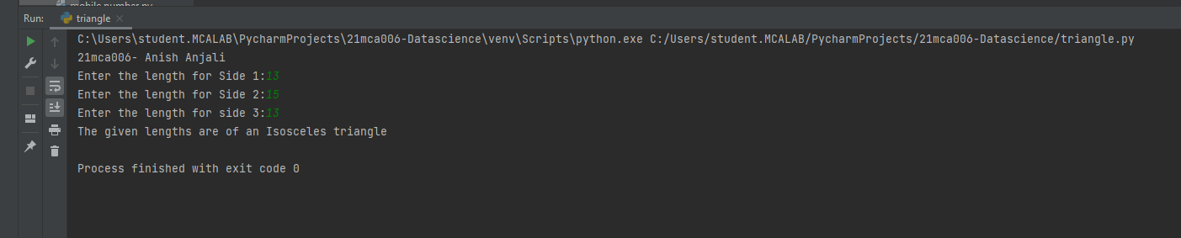

1. Program to check whether given pair of number is coprime

**CODE:**

**#4-check whether given pair of number is coprime**

**print("21mca006- Anish Anjali")**

**def are_coprime(a, b):**

**hcf = 1**

**for i in range(1, a + 1):**

**if a % i == 0 and b % i == 0:**

**hcf = i**

**return hcf == 1**

**first = int(input('Enter first number: '))**

**second = int(input('Enter second number: '))**

**if are_coprime(first, second):**

**print('%d and %d are CO-PRIME' % (first, second))**

**else:**

**print('%d and %d are NOT CO-PRIME' % (first, second))**

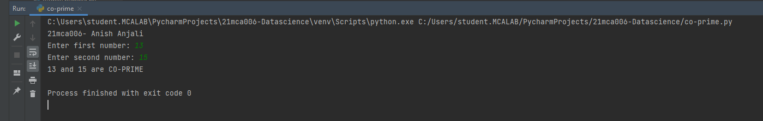

1. Program to find the roots of a quadratic equation(rounded to 2 decimal places)

**CODE:**

**#21mca006**

**#quadratic function**

**print("21mca006- Anish Anjali")**

**from math import sqrt**

**print("Quadratic function : (a * x^2) + b*x + c")**

**a = float(input("a: "))**

**b = float(input("b: "))**

**c = float(input("c: "))**

**r = b**2 - 4*a*c**

**if r > 0:**

**num_roots = 2**

**x1 = (((-b) + sqrt(r))/(2*a))**

**x2 = (((-b) - sqrt(r))/(2*a))**

**print("There are 2 roots: %f and %f" % (x1, x2))**

**elif r == 0:**

**num_roots = 1**

**x = (-b) / 2*a**

**print("There is one root: ", x)**

**else:**

**num_roots = 0**

**print("No roots, discriminant < 0.")**

**exit()**

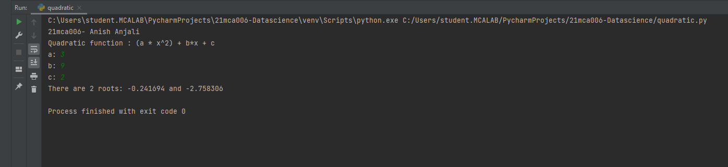

1. Program to check whether a given number is perfect number or not(sum of factors =number)

**CODE:**

**#6-perfect number**

**print("21mca006- Anish Anjali")**

**num = int(input("Enter any number: "))**

**sum = 0**

**for i in range(1, num):**

**if(num % i == 0):**

**sum = sum + i**

**if (sum == num):**

**print("The number is a PERFECT Number ")**

**else:**

**print("The number is NOT A PERFECT Number !")**

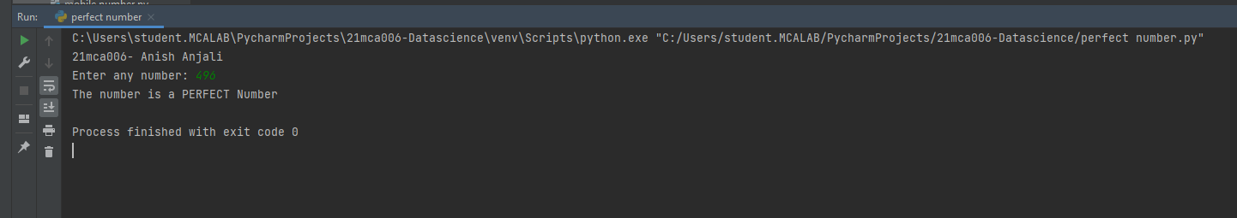

1. Program to display armstrong numbers upto 1000

**CODE:**

**#7- amstrong numbers**

**print("21mca006- Anish Anjali")**

**num = int(input("Enter a number: "))**

**sum = 0**

**temp = num**

**while temp > 0:**

**digit = temp % 10**

**sum += digit ** 3**

**temp //= 10**

**if num == sum:**

**print(num," is an amstrong number ")**

**else:**

**print(num,"is not an amstrong number !")**

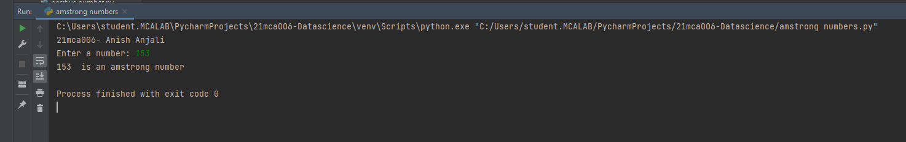

1. Store and display the days of a week as a List, Tuple, Dictionary, Set. Also demonstrate different ways to store values in each of them. Display its type also.

**CODE:**

**#21mca006**

**#List, Tuple, Dictionary, Set.**

**print("21mca006- Anish Anjali")**

**list1=["sunday","monday","tuesday","wednesday","thurday","friday","saturday"]**

**tuple=("sunday","monday","tuesday","wednesday","thurday","friday","saturday")**

**set={"sunday","monday","tuesday","wednesday","thurday","friday","saturday"}**

**dict={1:"sunday",2:"monday",3:"tuesday",4:"wednesday",5:"thurday",6:"friday",7:"saturday"}**

**print(list1,type(list1))**

**print(tuple,type(tuple))**

**print(set,type(set))**

**print(dict,type(dict))**

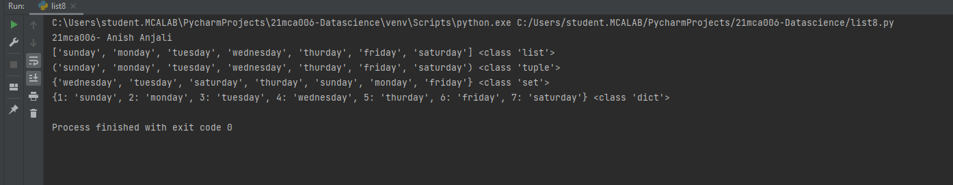

1. Write a program to add elements of given 2 lists

**CODE:**

**#21mca006**

**#add 2 list**

**print("21mca006- Anish Anjali")**

**lt1 = []**

**lt2 = []**

**lt3 = []**

**items = int(input(" Enter the total number of the list elements: "))**

**print(" Enter the items into List 1 : ")**

**for i in range(1, items + 1):**

**num = int(input(" Enter the value of %d index is :" % i))**

**lt1.append(num)**

**print(" Enter the items into the List 2 : ")**

**for i in range(1, items + 1):**

**num = int(input(" Enter the value of %d index is :" % i))**

**lt2.append(num)**

**for j in range(items):**

**lt3.append(lt1[j] + lt2[j])**

**print("\n Addition of the two lists is ", lt3)**

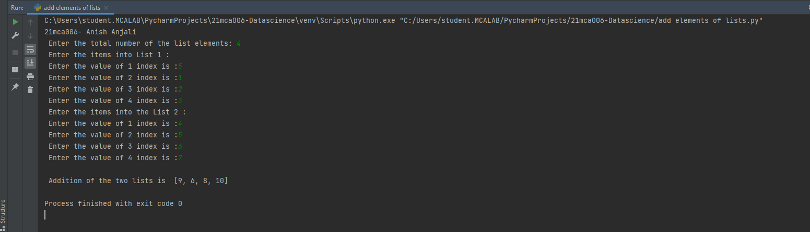

1. Write a program to find the sum of 2 matrices using a nested List.

**CODE:**

**#matrix**

**print("21mca006- Anish Anjali")**

**rows = int(input("Enter the Number of rows : "))**

**column = int(input("Enter the Number of Columns: "))**

**print("Enter the elements of First Matrix:")**

**matrix_a = [[int(input()) for i in range(column)] for i in range(rows)]**

**print("First Matrix is: ")**

**for n in matrix_a:**

**print(n)**

**print("Enter the elements of Second Matrix:")**

**matrix_b = [[int(input()) for i in range(column)] for i in range(rows)]**

**for n in matrix_b:**

**print(n)**

**result = [[0 for i in range(column)] for i in range(rows)]**

**for i in range(rows):**

**for j in range(column):**

**result[i][j] = matrix_a[i][j] + matrix_b[i][j]**

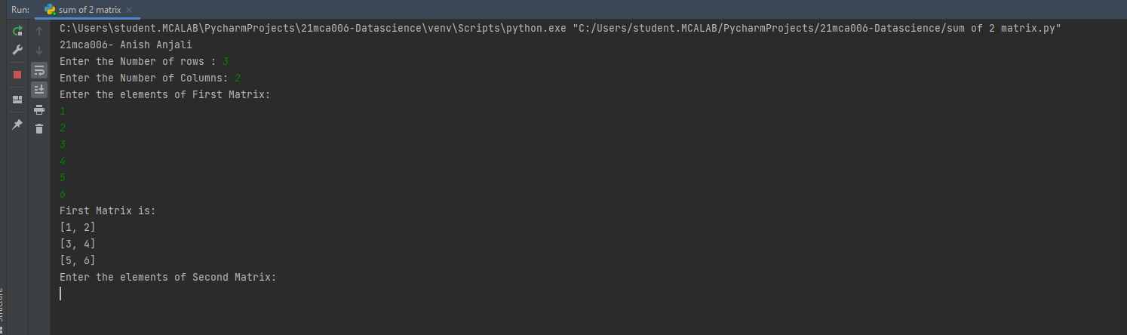

1. Write a program to perform bubble sort on a given set of elements.

**CODE:**

**#bubble sort**

**print("21mca006- Anish Anjali")**

**a = []**

**number = int(input("Please Enter the Total Elements : "))**

**for i in range(number):**

**value = int(input("Please enter the %d Item : " %i))**

**a.append(value)**

**for i in range(number -1):**

**for j in range(number - i - 1):**

**if(a[j] > a[j + 1]):**

**temp = a[j]**

**a[j] = a[j + 1]**

**a[j + 1] = temp**

**print("The Result in Ascending Order : ", a)**

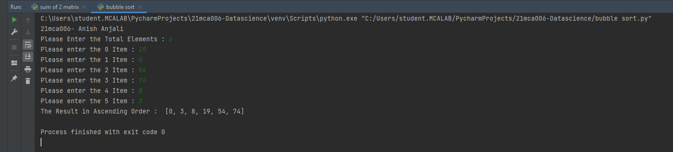

1. Program to find the count of each vowel in a string(use dictionary)

**CODE:**

**# 12- Python Program to Count Vowels in a String**

**print("21mca006- Anish Anjali")**

**str1 = input("Enter A String : ")**

**vowels = 0**

**for i in str1:**

**if (i == 'a' or i == 'e' or i == 'i' or i == 'o' or i == 'u'**

**or i == 'A' or i == 'E' or i == 'I' or i == 'O' or i == 'U'):**

**vowels = vowels + 1**

**print("Total Number of Vowels in this String = ", vowels)**

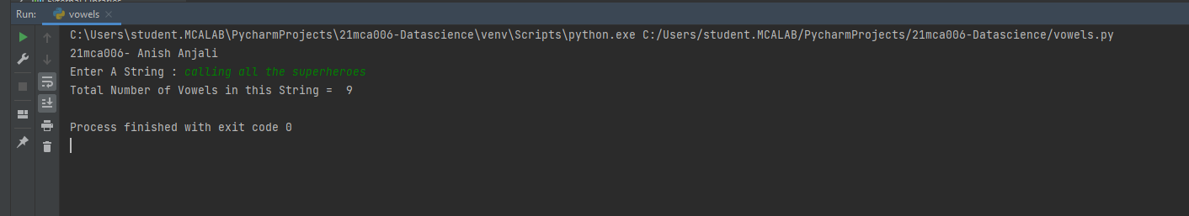

1. Write a Python program that accepts a positive number and subtract from this number the sum of its digits and so on. Continues this operation until the number is positive(eg: 256->2+5+6=13

256-13=243

243-9=232……..

**CODE:**

**#21mca006**

**#accepts a positive number and subtract from this number the sum of its digits.**

**print("21mca006- Anish Anjali")**

**num=int(input("Enter a positive number :"))**

**digsum=0**

**new_num=num**

**while new_num >= digsum:**

**list1 = [int(x) for x in str(new_num)]**

**for i in list1:**

**digsum=digsum+i**

**new_num=num-digsum**

**print(new_num)**

**print(new_num-new_num)**

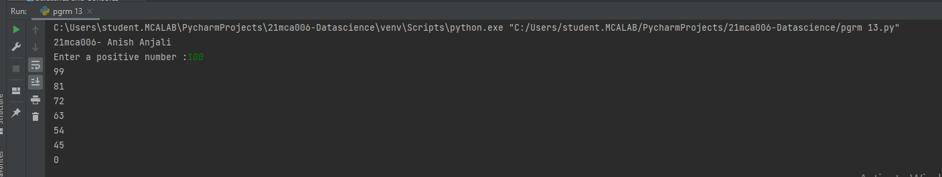

1. Write a Python program that accepts a 10 digit mobile number, and find the digits which are absent in a given mobile number

**CODE:**

**#21mca006**

**#absent numbers in a series of phone number**

**print("21mca006- Anish Anjali")**

**num = int(input("Enter a 10 digit mobile number : "))**

**nums = []**

**for i in range(0, 10):**

**n = num % 10**

**nums.append(n)**

**num = num // 10**

**print("numbers not in the mobile number are : ")**

**for i in range(0, 10):**

**if i not in nums:**

**print(i)**

